Table of Contents
Introduction 3
1. Data Preparation 5
1.1 Data Selection Rationale 5
1.1.1 Variable Selection - A Priori Logical Selection (Phase 1) 5
1.1.2 Temporal Selection 8
1.1.3 Record Selection 9
1.1.4 Sampling Strategy 9
1.1.5 Connection to Data Science Goals 11
1.2 Data Cleaning Process 12
1.2.1 Missing Data Treatment 12
1.2.2 Outlier Detection and Handling 14
1.2.3 Inconsistency Resolution 15
1.2.4 Error Correction 20
1.2.5 Impact Assessment 20
1.3 Feature Engineering 21
1.3.1 Derived Features 21
1.3.2 Transformations 23
1.3.3 Temporal Features 24
1.3.4 Domain Specific Features 24
1.3.5 Feature Justification 26
1.4 Data Integration and Final Preparation 28
1.4.1 Integration Approach 28
1.4.2 Data Formatting 28
1.4.3 Train/Validation/Test Splitting 29
1.4.4 Final Dataset Characteristics 29
1.4.5 Preparation Pipeline 34
2. Modelling 36
2.1 Modelling Strategy 36
2.1.1 Problem Framing 36
2.1.2 Algorithm Selection Rationale 36
2.1.3 Evaluation Strategy 36
2.1.4 Computational Considerations 37
2.1.5 Connection to Data Science Goals and Success Criteria 37
2.2 Model Development 37
2.2.1 Baseline Model 37
2.2.2 Primary Models 40
2.2.3 Computational Requirements 47
2.2.4 Model Interpretation 49
2.3 Model Evaluation and Comparison 51
2.3.1 Performance Metrices 51
2.3.2 Comparative Analysis 52
2.3.3 Diagnostic Evaluation 52
2.3.4 Robustness Testing 52
2.3.5 Organizational Metric Translation 52
2.4 Model Selection and Recommendations 53
2.4.1 Selected Model 53
2.4.2 Selection Justification 53
2.4.3 Limitations and Risks 54
Conclusion 56
References 57

Data Preparation and Modeling Report

Introduction
The Consumer Safety Research Institute (CSRI) is a specialized fictional nonprofit organization established in 2012 to perform independent research on consumer product safety and publish reports and insights that defines public disclosure, and aids in policy decisions. The domain of consumer product safety is currently characterized by a significant disconnect between available data and public understanding. the prevailing public discourse frequently relies on anecdotal evidence, high-profile media incidents, or biased manufacturer marketing rather than systematic, empirical analysis. This reliance on incomplete information leaves consumers, policymakers, and safety advocates without the evidence-based insights necessary for informed decision-making. This information gap creates a critical challenge in an environment where stakeholders increasingly demand rigorous, independent verification to distinguish between isolated accidents and genuine systemic risks. There is a pressing market need for an authoritative intermediary capable of translating dense surveillance data into clear, actionable intelligence.
The primary objective of the project is to develop predictive models to identify which consumer product injuries are most likely to result in hospitalization and determine what factors—product categories, demographics, injury characteristics—predict severe medical outcomes among emergency department cases, producing evidence-based findings that inform CSRI's 2025 Product Safety Spotlight report and contribute to public understanding of consumer product safety priorities. The secondary objective of the project is to Identify temporal and demographic trends in consumer product injury severity patterns, including seasonal variations, changes over time, and emerging patterns that may indicate shifting safety concerns, generate insights about demographic patterns in severe product injuries that inform targeted safety messaging, and create analytical.

approaches that enhance CSRI's reputation as a leading source of independent consumer safety research.
Primary data science goal is to establish statistically significant correlations between factors contributing to physical injuries and hospitalization due to the use of consumer products with a high degree of confidence; secondary goal is to create interpretable models that quantify effect sizes for public communication. This dataset description document will explain in detail the datasets used for the modelling and any major analysis work of the project.

Data Preparation
The data preparation phase is divided into five key stages. The subsequent sections will extensively describe our methodology for executing each:
- Data Selection
- Data Cleansing
- Data Construction
- Data Integration
- Data Formatting

Data Selection Rationale

Variable Selection - A Priori Logical Selection (Phase 1)
Variable selection was executed in two iterative passes to align with CRISP-DM principles while accommodating engineered features.
In Phase-1, we perform the dimensionality reduction based on Data Quality audit and business logic. We will perform another phase of variable selection after the Feature Engineering/Data Construction phase.

The NEISS dataset has a total of 26 features /variables and below is the list of features that we are planning to consider/omit.

The below table summarizes the percentage of NULL data from the consolidated dataset.

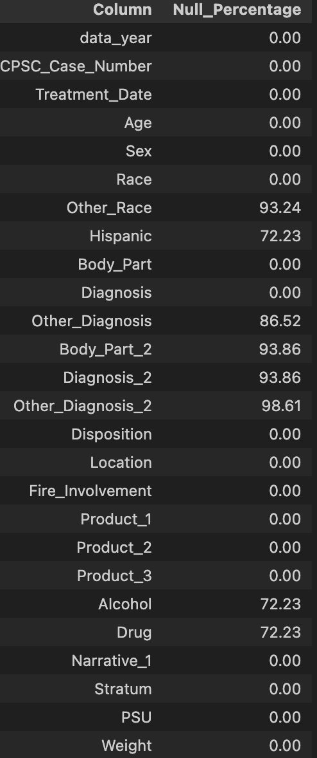
Based on the above information, the below table defines the if we need to include/exclude a feature and the corresponding reasoning.

Excel/Tab Variable | Include/Exclude | Include/Exclude Reason
CPSC_Case_Number | Exclude | This is a record identifier and does not hold any predictive value.
Treatment_Date | Include | Helps to define the treatment year/month. Valuable for timeseries analysis.
Age | Include | Can be used for prediction.
Sex | Include | Can be used for prediction.
Race | Include | Understand the demography of ER admissions.
Other_Race | Exclude | Only used when Race = 3 (Other) and 93% of the values are null.
Hispanic | Exclude | Available only from 2019 and 73% of the records have a NULL value.
Body_Part | Include | Will help to understand the relation between hospitalization and the injured body part.
Body_Part_2 | Exclude | 94% of the records have a NULL value. Added to log the injury to the secondary body part.
Diagnosis | Include | Will help to understand the relation between hospitalization and the injury.
Diagnosis_2 | Exclude | 93% of the records have a NULL value. Available only from 2019.
Other_Diagnosis | Exclude | Only used when the diagnosis is 71 - Other. 86% of the records have a NULL value.
Other_Diagnosis_2 |  | 98% of the records have a NULL value. Only used with diagnosis code 71 - Other.
Disposition | Include | This can be used to generate the target variable. (Hospitalized - Yes/No). But we exclude this feature for modelling as this variable is not available at the time of prediction.
Location | Include | Can be used to gain insights into the where the injury happened.
Fire_Involvement | Include | Use this along with the narrative field to decide if there was a fire involvement.
Alcohol | Include | Use this along with the narrative field to decide if there was an alcohol involvement.
Drug | Include | Use this along with the narrative field to decide if there was an alcohol involvement.
Product_1 | Include | Helps to understand what product caused the injury.
Product_2 | Include | Helps to understand what product caused the injury.
Product_3 | Exclude | Only available from 2019.
Narrative | Include | Can derive insights into the nature of injury and cause.
Stratum | Exclude | Defines the hospital where the treatment happened and does not technically define the disposition.
PSU | Exclude | Defines the hospital where the treatment happened and does not technically define the disposition.
Weight | Include | Included as we can calculate national estimates using this attribute.

Temporal Selection
The NEISS data is available for the last 20 years. An a priori data selection was applied on the dataset to ensure longitudinal continuity and to maintain seasonal bias. The analysis was restricted to the full calendar year data for the last 6 years 2018 – 2024. The last 6 years were selected to minimize the risk of trends caused by CPSC product taxonomy revisions.
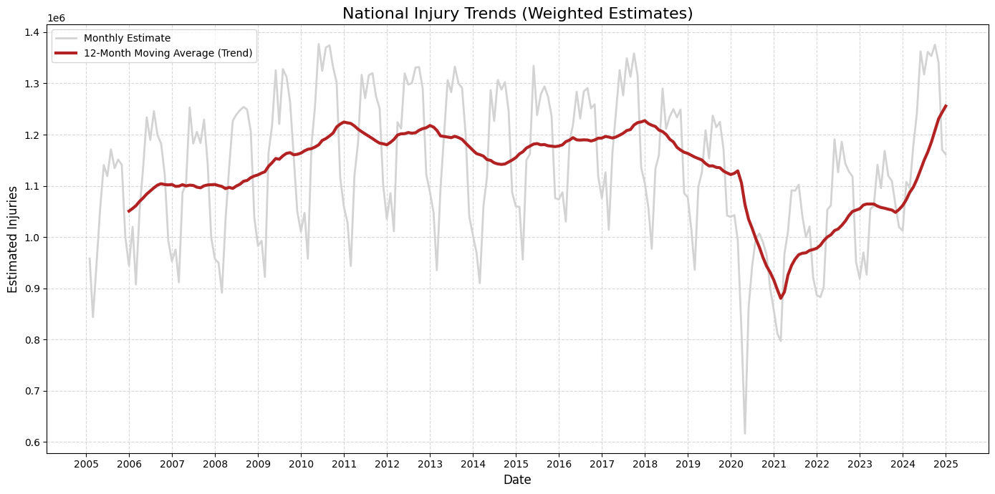
Furthermore, the data from the year 2020 can be included for the analysis to understand the timeseries/seasonal trend but will be avoided from the modelling dataset due to the shift in the consumer behavior and hospital admittance due to the COVID-19 pandemic.
Test Data Year: 2018 – 2021 (Excluding 2020)
Validation Data year: 2022 – 2023
Holdout Data year: 2024

Record Selection
The record selection dictates which rows from the initial dataset makes to the final dataset. No specific record selection was performed other than temporal selection.

Sampling Strategy

Use Stratified Sampling:
To construct the Train (70%), Validation (15%), and Hold-Out (15%) subsets, a temporally stratified sampling technique is utilized.

To address the dual challenges of a highly imbalanced target variable and temporal data anomalies, a composite stratification methodology was engineered for the train-test split. A synthetic composite key was generated by concatenating the 'Treatment_Year' and the binary 'Disposition' (Hospitalized vs. Released) variables. By utilizing this composite key as the stratification target, the partitioning algorithm mathematically guaranteed that the historical temporal distribution—including macro-anomalies like the 2020 pandemic—and the severe injury class imbalance were perfectly preserved across all data folds. This approach ensures the predictive model is evaluated on a truly representative cross-section of the entire historical timeline without geographic or temporal clustering.

Given the significant shifts in consumer behavior and injury mechanisms resulting from macro-environmental factors (e.g., the 2020 COVID-19 pandemic), a standard randomized split posed a risk of temporal bias. By stratifying the split explicitly on a special composite variable, the exact annual distribution of the overarching dataset was perfectly preserved across all three data partitions, ensuring the machine learning algorithms could identify consistent longitudinal trends without being skewed by isolated annual anomalies.
The stratified data partitioning was accomplished by creating a composite key composed of Data Year and Hospitalization (Yes or No – derived from Disposition Code).
By stratifying your train/test split on the new data_year_hospitalized key, helps guaranty two things simultaneously:
Every year is represented equally in the training and test sets.
The exact ratio of severe vs. minor injuries is preserved within every single year. This perfectly insulates the machine learning model against historical anomalies (like COVID-19 lockdowns in 2020) while maintaining the real-world imbalance of your target variable.
The disposition feature is highly imbalanced and more than 85% of the cases are “treated and released” thereby creating a massive imbalance. If we train the model with this imbalance, the model will always classify the injury as minor (Majority class). We need to hence apply Majority Under sampling on the training set there by forcing the model to learn the mathematical difference between a minor Vs major injury. This step needs to be performed when splitting the data into train, evaluation and hold out sets.

Balancing the training data:
To address heavy class imbalance, Random Under sampling of majority class is applied on the training dataset to establish a 1:1 class ratio that optimizes, algorithmic learning with out distorting the data distribution in the hold-out/test dataset. This step will need to be performed during the model training phase.

Connection to Data Science Goals

Data Cleaning Process

Missing Data Treatment
Below table summarizes the list number and percentage of records with NULL and Unknown Data.
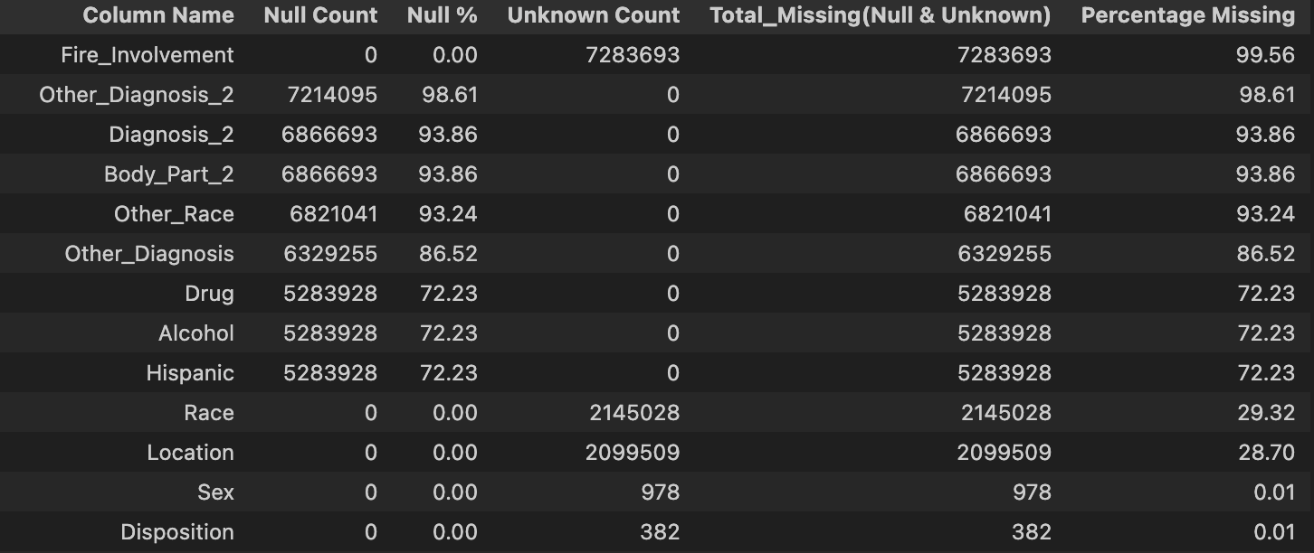

Treating NULL Values
Column Name | Null/Missing-Unknown? | Treatment Description
Other Diagnosis 2 | NULL | 93% of the records have a NULL value. Available only from 2019. This feature holds the description of the diagnosis. Fill the NULL values with the text "UNKNOWN"
Diagnosis 2 | NULL | 98% of the records have a NULL value. Only used with diagnosis code 71 - Other.
Body Part 2 | NULL | 94% of the records have a NULL value. Added to log the injury to the secondary body part. Defines the secondary body part code - fill it with '87' - Not stated/Un Known.
Other Race | NULL | Only used when Race = 3 (Other) and 93% of the values are null. This feature describes the Race as a text. For records with a NULL value, we can fill with the text "OTHER" and consider it as a separate class.
Other Diagnosis | NULL | Only used when the diagnosis is 71 - Other. 86% of the records have a NULL value. This feature is filled with description of the diagnosis. We can fill the NULL values with the text 'UNKNOWN' to consider it as a separate class.
Drug | NULL | Use of Drugs or Medication Contributed to the Incident or the Severity of the Injury - available from 2019.  There are 2 categories of values in the field.  0 =No/No Information  1 = Yes  Fill the NULL values with a new value "3" to consider it as a separate class.
Alcohol | NULL | Use of Drugs or Medication Contributed to the Incident or the Severity of the Injury - available from 2019.  There are 2 categories of values in the field.  0 =No/No Information  1 = Yes  Fill the NULL values with a new value "3" to consider it as a separate class.
Hispanic | NULL | There are three categories of observations  1. 0 - Unknown  2. 1 - Yes  3. 2 - No  For records with NULL values, we can fill with a 0 (Unknown)

Treating UNKNOWN Values

Column Name | Null/Missing-Unknown? | Treatment Description
Fire Involvement | Unknown | 99% of the records does not have a value - we can treat this as a category and will not substitute.
Race | Unknown | 29% of the records does not have a value - we can treat this as a category and will not substitute.
Location | Unknown | 28% of the records does not have a value - we can treat this as a category and will not substitute.
Sex | Unknown | Less than 1% of the values does not have a Sex. We can substitute these records with the common Sex value - Male (1)
Disposition | Unknown | Roughly 382 records do not have a disposition - we need to know the disposition to decide if a patient was hospitalized or not. we have two options.  1. Drop these records as the count is <1%  2. Classify these records as 'Not Hospitalized' when we perform the feature engineering.  We will choose **#2** at this juncture.

Missing Values in the Age
The Age feature contained missing values that required mathematical imputation to maintain algorithmic stability. To strictly prevent data leakage, a median imputation strategy was deployed post-partitioning. The median age was calculated exclusively derived from the Training subset. This static scalar value was subsequently applied to fill missing values within the Training, Validation, and Hold-Out test sets. This ensured that the evaluation partitions were cleansed without their underlying distributions influencing the imputation logic.

Outlier Detection and Handling

The outlier detection and handling need to be executed as a two-phase iterative approach to ensure data integrity across the CRISP-DM life cycle. We will initially perform the detection and cleaning using the raw data where we evaluate the data for physical impossibility and data entry errors. We will need to perform the outlier detection and cleansing after the feature engineering phase to again make sure that there are no anomalies in the newly engineered features.

Categorical Outliers
Outlier detection was performed on categorial features and we identified the below exceptions.
- 147 products had fewer than 100 injuries and can be binned together as like “low-frequency-products”.
- Narratives for 10 records were less than 10 bytes. We should ignore the narratives of these 10 rows.

Numerical Outliers
- Age is the only numerical feature in the dataset, and this column needs transformation before checking for outliers. We will need to perform outlier detection on this feature after inconsistency resolution.

Date Outliers
- No outliers found in the Treatment date feature.

Inconsistency Resolution

- Product Code Inconsistency
47 products show inconsistent reporting and show sudden death/birth and indicates reclassification to another product code or an expiry. We need to harmonize the product codes or bin the codes.
Impacted product codes:
[394, 556, 569, 574, 876, 897, 899, 1132, 1145, 1317, 1329, 1381, 1394, 1395, 1417, 1465, 1466, 1527, 1543, 1545, 1552, 1606, 1618, 1620, 1629, 1706, 1707, 1710, 1841, 1855, 1909, 3215, 4802, 5004, 5016, 5017, 5019, 5020, 5021, 5022, 5023, 5024, 5025, 5042, 5043, 5045, 5046]
The legacy product codes were reclassified to the modern codes to ensure longitudinal consistency. Refer to the official CPSC documentation (U.S. Consumer Product Safety Commission, 2018) that explains the complete crosswalk methodology for product remapping. Below is the summary of the action that we have taken for the 47 products that needs to be harmonized.

Product ID | Reclassified Product ID | Injury Year | Comments
394 | 394 | 2006- Present | New Product - Do not reclassify/bin
556 | 556 | 2005- Present | Current - No need to reclassify
569 | Combine 514, 564 to 569 | 2005- Present | Combines 0514 and 0564
574 | 5016 |  | New code added in 2008
876 | Combine 865, 873, 876 to 897 | 2005 product | Expansion of 0806 along with 0865 & 0873. In 2006, merged with 0865 and 0873 to make 0897
897 | 5016
899 | 5016
1132 | Combine 1332, 1383,1306, 1317, 1318, 1356, 5004 to 5021(Toy Vehicles) | 2005 product | Expansion of 1108 along with 1130 & 1131. Deleted in 2005.  In 2010, discontinued use of product  codes 1332, 1383, 1306, 1317, 1318,  1356, and 5004, and merged into 5021.
1145 | Replace 1855 with 1145 | 2006- Present | Name change. Replaces 1855
1317 | 5021 | 2005-2009 | In 2010, merged with 5 other codes and replaced by 5021 and 5017.  One->Many Taxonomy
1329 | 5023
1381 | 1381 | 2010-2024 | Current - No need to reclassify
1394 | 1394 | 2010-2024 | Current - No need to reclassify
1395 | 1395 | 2010-2024 | Current - No need to reclassify
1417 | 1417, 1465, 1466 to Decorative Yard Equipment | 2005-2008 | Incorporates part of 0124. Deleted in  NEISS 12/94. Restored in NEISS 5/00.  Split into 1465 and 1466 in 2009.  One - Many Taxonomy - Convert to Decorative Yard Equipment
1465 | Decorative Yard Equipment | 2009-2024 | Split from 1417
1466 | Decorative Yard Equipment | 2009-2024 | Split from 1417
1527 | 1527
1543 | 1552
1545 | 1552
1552 | 1552 | 2021-2024 | Current - No need to reclassify
1606 | 1606 | 2005-2010 | Effective 2011, for use in Trauma hospitals only
1618 | 1618 | 2005-Present | Current - No need to reclassify
1620 | 1620 | 2005- Present | Current - No need to reclassify
1629 | 1629 | 2005-Present | Current - No need to reclassify
1706 | 1706 | 2005-2010 | Effective 2011, for use in Trauma hospitals only
1707 | 1707 | 2005-2010 | Effective 2011, for use in Trauma hospitals only
1710 | 1710 | 2005-2010 | Effective 2011, for use in Trauma hospitals only
1841 | 1841 | 2005-2017 | Expansion of 1801 along with 1842 & 1843
1855 | 1145 | 2005 product | Deleted in 2005, and replaced with 1145
1909 | 1909 | 2005-2008 | Effective 2011, for use in Trauma hospitals only
3215 | 3215 |  | Expansion of 3204 along with 3258
4802 | 4802 | 2010-2024 | Current - No need to reclassify
5004 | 1395 |  | Effective January 1, 2010, there was a major revision of the “toy codes.” The product code 5004/Toys, not elsewhere classified was replaced by several new codes, including 1395/Toys, not specified and 1381/Toys, not elsewhere classified, along with the implementation of a number of new toy codes to capture and refine the coding of products formerly coded as 5004.  Mapping to the general Toys product.
5016 | 5016 | 2009-2024 | Current - No need to reclassify
5017 | Off-Road Vehicles (ATV/UTV)
5019 | Off-Road Vehicles (ATV/UTV)
5020 | Off-Road Vehicles (ATV/UTV)
5021 | Off-Road Vehicles (ATV/UTV)
5022 | Micromobility (Scooters/Hoverboards)
5023 | Micromobility (Scooters/Hoverboards)
5024 | Micromobility (Scooters/Hoverboards)
5025 | Micromobility (Scooters/Hoverboards)
5042 | 5022
5043 | Off-Road Vehicles (ATV/UTV)
5045 | Power-Assisted Cycles (E-bikes)
5046 | Power-Assisted Cycles (E-bikes)

- Age Vs Product Inconsistency
There are around 776 suspicious cases of infants using adult products. As the number of such records are very minimal – we can delete these records.

Error Correction

Unit of Measure Standardization (Infant Age):
The raw NEISS Age variable exhibited a structural inconsistency by combining two distinct units of measurement within a single numeric vector. While patients aged two years and older are recorded in integer years, infants under two years are recorded in months, prefixed with a "2" (e.g., a 6-month-old is coded as 206). To resolve this inconsistency and prevent machine learning algorithms from interpreting infants as >200-year-old outliers, a programmatic transformation was applied. All values of age greater than 200 were isolated, the prefix was stripped, (by subtracting 200 from the age) and the remaining months were converted into fractional years (divided by 12 months). This harmonized the entire column into a single, continuous unit of measurement (Years). Refer the Age section in Neiss Coding Manual January 2025(Rev.1). (n.d.). for more details.

Duplicate Check:
A duplicate check was performed on the dataset to confirm that the injury data is not duplicated in the dataset. No duplicate data was observed in the dataset – No correction applied.

Impact Assessment

The Data cleaning process reduced dataset from 7315732 to 7314956 records (0.01 % loss). Most of the data in the NEISS dataset is already clean and the only scenario that needed the amputation was due to a data inconsistency that we observed when we compared the patient age with the product involved in the injury.

Feature Engineering
To ensure structural parity across all data partitions while strictly preventing data leakage, feature engineering was bifurcated. Row-independent derivations (e.g., Hospitalization, Data Year) were applied globally prior to partitioning. Conversely, dataset-dependent transformations, such as numeric scaling and categorical encoding, were strictly fitted exclusively on the Training partition. The resulting transformation parameters were subsequently applied blindly to the Validation and Hold-Out partitions, preserving the pristine, unseen nature of the evaluation data.

Derived Features

The below features were derived from the original dataset

True Alcohol

The Alcohol feature in the dataset is only available from 2019 onwards and hence more than 72.23% unknown value. This field is added to derive any insights from the Narrative attribute indicating the usage of Alcohol before or during the occurrence of the injury.

Methodology:
- Text-Mining for Substance Usage: Parsed the text within the Narrative feature for specific alcohol-related keywords to construct a preliminary Alcohol_Narrative Boolean flag.
- Composite Feature Generation: Applied a logical inclusive-OR operation between the newly derived Alcohol_Narrative flag and the baseline Alcohol variable to engineer a master True_Alcohol feature, ensuring all documented instances of alcohol involvement were captured.

Alcohol Keywords:
'ALCOHOL', 'ETOH', 'INTOXICATED', 'INEBRIATED', 'DRUNK',
'SOBER', 'BAC ', 'BEER', 'WINE', 'LIQUOR', 'VODKA', 'WHISKEY', 'WHISKY', 'TEQUILA', 'RUM', 'GIN', 'BRANDY', 'CHAMPAGNE', 'MOONSHINE', 'DRINKING', 'PARTY', 'BAR', 'PUB', 'CLUB', 'TAVERN',
'HAPPY HOUR', 'KEG'

True Drug

The Drug feature in the dataset is only available from 2019 onwards and hence more than 72.23% unknown value. This field is added to derive any insights from the Narrative attribute indicating the substance usage of before or during the occurrence of the injury.

Methodology:
- Text-Mining for Substance Usage: Parsed the text within the Narrative feature for specific drug-related keywords to construct a preliminary Drug_Narrative Boolean flag.
- Composite Feature Generation: Applied a logical inclusive-OR operation between the newly derived Drug_Narrative flag and the baseline Drug variable to engineer a master True_Drug feature, ensuring all documented instances of drug involvement were captured.
Drug Keywords:
'DRUG', 'OVERDOSE', 'MEDICATION', 'PILL', 'TABLET', 'CAPSULE',
'INGEST', 'SUBSTANCE', 'NARCOTIC', 'OPIOID', 'OPIGTE', 'COCAINE', 'HEROIN', 'METHAMPHETAMINE', 'MARIJUANA', 'CANNABIS', 'FENTANYL', 'ECSTASY', 'MDMA', ' LSD ', ' PCP ', 'HASHISH','XANAX', 'VALIUM', 'PERCOCET', 'VICODIN', 'OXYCODONE', 'OXYCONTIN', 'ADDERALL', 'RITALIN', 'TYLENOL', 'ASPIRIN', 'IBUPROFEN', 'ADVIL', ‘MOTRIN', 'BENADRYL', 'INSULIN', 'VITAMIN', 'MORPHINE', 'CODEINE'

Treatment Month
Derive this feature from the Treatment Date Feature

Transformations

Transformation applied on Categorical Features

Product_1:
The primary independent variable, Product_1, exhibits a high cardinality (837 unique discrete values). To prevent the Curse of Dimensionality and computational degradation associated with standard One-Hot Encoding, a Target Encoding (Mean Encoding) strategy is employed. The categorical product codes were transformed into continuous numeric variables representing their historical probability of the target class (Hospitalized). To strictly prohibit target leakage, the encoding probabilities were fitted exclusively on the Training partition, utilizing statistical smoothing to penalize low-frequency categories, before being mapped to the Validation and Hold-Out datasets.

Diagnosis, Body Part, Location, Body Part 2, EMS/Severity Escalation, Safety Equipment Utilization, Third-Party Intervention, Height Risk, and Water Risk
One-Hot Encoding was applied to the nominal categorical features to prevent the algorithms from inferring false ordinal relationships. Because these variables have no inherent mathematical ranking, transforming them into distinct binary vectors (0s and 1s) is a mathematical prerequisite. This ensures the predictive model evaluates the distinct presence or absence of each category without falsely associating magnitude or hierarchy. We chose one hot encoding due to the low cardinality of these features.

Transformation applied on Numeric Features
The continuous numerical feature 'Age' was transformed using a Standard Scaler (Z-score normalization) to enforce a mean of 0 and a standard deviation of 1. This standardization ensures that the feature's original magnitude does not disproportionately influence spatial calculations. It is a critical mathematical prerequisite for distance-based machine learning algorithms—such as K-Nearest Neighbors or Support Vector Machines—which rely on Euclidean or Manhattan metrics and are highly sensitive to unscaled variances."

Temporal Features

Treatment Year
The treatment year has been derived from the treatment date.

Treatment Month
The treatment month has been derived from the treatment date.

Domain Specific Features

EMS/Severity Escalation, Safety Equipment Utilization, Third-Party Intervention, Height Risk, and Water Risk
To augment the predictive capacity of the baseline categorical variables, rule-based Natural Language Processing (NLP) was applied to the unstructured clinical narratives. A series of deterministic regular expression (Regex) algorithms were developed to extract high-value contextual vectors that are historically under-coded in the CPSC taxonomy. This yielded five distinct binary features: EMS/Severity Escalation, Safety Equipment Utilization, Third-Party Intervention, Height Risk, and Water Risk. These boolean indicators provide the classification algorithms with critical micro-environmental context necessary for accurately predicting hospitalization probability.

Injury Mechanism:
To capture the root behavioral cause of the incidents, a new categorical feature, Injury_Mechanism, was engineered from the unstructured Narrative column. A deterministic Regular Expression (Regex) algorithm was deployed to scan the 142-character text vectors for standardized keyword groups, effectively categorizing raw clinical text into five distinct quantitative mechanisms (e.g., Fall, Burn, Ingestion). Narratives lacking these specific keyword patterns were binned as 'Other/Unspecified' to maintain dataset dimensionality without introducing speculative bias.

Feature Justification

True Alcohol

The 'Alcohol' flag indicates whether a patient consumed alcohol in relation to their incident. Because this dedicated variable was only introduced to the dataset in 2019, approximately 73% of historical records are structurally missing this information. However, prior to 2019, hospital staff frequently documented alcohol or substance involvement directly within the unstructured 'Narrative' feature using common clinical keywords. By applying text-mining techniques to extract these keywords, we can retroactively derive and impute the missing alcohol flags. Recovering this critical behavioral data will empower the machine learning algorithms to mathematically isolate correlations between alcohol consumption and overall injury severity.

True Drug

The ‘Drug; flag indicates whether a patient consumed substance/drug in relation to their incident. Because this dedicated variable was only introduced to the dataset in 2019, approximately 73% of historical records are structurally missing this information. However, prior to 2019, hospital staff frequently documented drug/substance involvement directly within the unstructured 'Narrative' feature using common clinical keywords. By applying text-mining techniques to extract these keywords, we can retroactively derive and impute the missing drug flags. Recovering this critical behavioral data will empower the machine learning algorithms to mathematically isolate correlations between substance consumption/abuse and overall injury severity.

Treatment Year and Treatment Year
Temporal variables, specifically 'Treatment_Year' and 'Treatment_Month', were extracted from the raw 'Treatment_Date' feature to capture two distinct chronological patterns. The 'Month' variable enables the algorithm to identify cyclical, seasonal behaviors in product-related injuries, while the 'Year' variable contextualizes macro-level historical anomalies, such as the dramatic shifts in injury rates documented during the COVID-19 pandemic.

EMS Severity Flag
Extracting the 'EMS/Severity' flag from the unstructured narratives provides a critical proxy for initial incident perception. By capturing the specific mode of medical transport—such as distinguishing a critical helicopter airlift from a standard ambulance response—we engineer a feature that inherently signals trauma level. This allows the predictive algorithms to mathematically weight these emergency escalation events when correlating incident details with the final injury severity.

Safety Gear Flag
Extracting a 'Safety Gear' flag from the unstructured narratives introduces a critical mitigating variable to contextualize the baseline trauma. For instance, sustaining a head impact while wearing a helmet typically results in a distinctly different clinical trajectory compared to an unprotected incident. Integrating this feature allows the classification algorithms to mathematically weigh the protective effect of safety equipment when predicting the patient's final clinical disposition.

Third Party Flag
Extracting the third party flag from the narrative alos plays a critical role in

Height Risk Flag

Water Risk Flag

Injury Mechanism

Data Integration and Final Preparation

Integration Approach
This project employed a single-source methodology utilizing only the NEISS database. External data integration was excluded from the project scope, as the native incident records provided sufficient dimensionality for predictive modeling. The integration effort was therefore strictly internal, focusing on appending newly engineered features—derived from text-mining the clinical narratives—into the core dataset to enrich the model's predictive context.

Data Formatting

Type Casting: Converted raw Treatment Date into standard Python datetime objects to allow for precise temporal slicing.

String Standardization: Forced all 142-character narratives into uppercase formatting to ensure the Regex extraction algorithms were case-insensitive and mathematically stable.

Categorical Binarization: Applied One-Hot Encoding to reformat nominal text variables into algorithm-compatible binary matrices (0/1), satisfying the strict numeric input requirements of the predictive models. Target Encoding was used on the Product_1 field due to high cardinality.
Structured data in wide format with one row per injury case and columns for each feature, ensuring all numeric features are float type, categorical variables are properly encoded, and target variable is properly encoded as binary 0/1

Train/Validation/Test Splitting

Used 70/15/15 (for the Train/Evaluation/Holdout) split with stratification on the composite target variable (Year and Hospitalized) to ensure equal class representation across sets, with temporal ordering preserved to simulate real-world prediction scenarios.

Final Dataset Characteristics

The final dataset provided to the machine learning algorithms represents a highly optimized, signal-dense feature space. To arrive at these final characteristics, a secondary, post-engineering selection phase was conducted on the fully enriched dataset. We applied Chi-Square Tests of Independence and Cramér's V calculations as a final statistical gatekeeper across both native and engineered features. Consequently, the final dataset excludes all low-impact noise and retains only the variables—such as the engineered EMS/Severity flag and the native Age feature—that mathematically demonstrated a significant and robust correlation with the target patient disposition.

The final dataset contains 7,314,956 rows and 99 features.
Hospitalized? | Count | Ratio
0 | 6,650,119 | 91
1 | 664,837 | 9

The dataset is severely imbalanced with 91:9 for the target variable.

Record Count (Train/Evaluation/Holdout)
Below is the split of the number of records between train, evaluation and holdout datasets.
Dataset | Record Count | Percentage | Feature Count
Train | 5,120,468 | 70% | 99
Evaluation | 1,097,244 | 15% | 99
Holdout | 1,097,244 | 15% | 99
Total | 7,314,956 | 100% | 99

Count of Data by Target Variable

Dataset | Hospitalized? | Count | Ratio
Train | 0 | 4655082 | 90.91
Train | 1 | 465386 | 9.09
Evaluation | 0 | 997519 | 90.91
Evaluation | 1 | 99725 | 9.09
Holdout | 0 | 997518 | 90.91
Holdout | 1 | 99726 | 9.09

We can see that the data is split in a stratified manner by target variable.

Temporal Stratified Record Volume

Treatment Year | Hospitalized | Count
2005 | 0 | 236967
2005 | 1 | 15254
2006 | 0 | 238747
2006 | 1 | 15748
2007 | 0 | 242403
2007 | 1 | 16439
2008 | 0 | 244657
2008 | 1 | 17293
2009 | 0 | 254571
2009 | 1 | 19747
2010 | 0 | 263406
2010 | 1 | 20564
2011 | 0 | 257017
2011 | 1 | 20500
2012 | 0 | 254802
2012 | 1 | 21240
2013 | 0 | 241922
2013 | 1 | 21896
2014 | 0 | 236169
2014 | 1 | 21056
2015 | 0 | 229419
2015 | 1 | 21950
2016 | 0 | 238688
2016 | 1 | 23927
2017 | 0 | 244791
2017 | 1 | 26011
2018 | 0 | 225755
2018 | 1 | 27390
2019 | 0 | 223061
2019 | 1 | 28016
2020 | 0 | 187255
2020 | 1 | 29286
2021 | 0 | 208390
2021 | 1 | 29897
2022 | 0 | 198672
2022 | 1 | 27652
2023 | 0 | 207123
2023 | 1 | 29635
2024 | 0 | 221267
2024 | 1 | 31885

We can see that the data is split in a stratified manner by treatment year and target variable.

Feature List in the Final Dataset

Feature List
cat__Diagnosis_41
cat__Diagnosis_42
cat__Diagnosis_46
cat__Diagnosis_47
cat__Diagnosis_48
cat__Diagnosis_49
cat__Diagnosis_50
cat__Diagnosis_51
cat__Diagnosis_52
cat__Diagnosis_53
cat__Diagnosis_54
cat__Diagnosis_55
cat__Diagnosis_56
cat__Diagnosis_57
cat__Diagnosis_58
cat__Diagnosis_59
cat__Diagnosis_60
cat__Diagnosis_61
cat__Diagnosis_62
cat__Diagnosis_63
cat__Diagnosis_64
cat__Diagnosis_65
cat__Diagnosis_66
cat__Diagnosis_67
cat__Diagnosis_68
cat__Diagnosis_69
cat__Diagnosis_71
cat__Diagnosis_72
cat__Diagnosis_73
cat__Diagnosis_74
cat__Body_Part_0
cat__Body_Part_30
cat__Body_Part_31
cat__Body_Part_32
cat__Body_Part_33
cat__Body_Part_34
cat__Body_Part_35
cat__Body_Part_36
cat__Body_Part_37
cat__Body_Part_38
cat__Body_Part_75
cat__Body_Part_76
cat__Body_Part_77
cat__Body_Part_79
cat__Body_Part_80
cat__Body_Part_81
cat__Body_Part_82
cat__Body_Part_83
cat__Body_Part_84
cat__Body_Part_85
cat__Body_Part_87
cat__Body_Part_88
cat__Body_Part_89
cat__Body_Part_92
cat__Body_Part_93
cat__Body_Part_94
cat__Location_0
cat__Location_1
cat__Location_2
cat__Location_4
cat__Location_5
cat__Location_6
cat__Location_7
cat__Location_8
cat__Location_9
cat__Body_Part_2_0.0
cat__Body_Part_2_30.0
cat__Body_Part_2_31.0
cat__Body_Part_2_32.0
cat__Body_Part_2_33.0
cat__Body_Part_2_34.0
cat__Body_Part_2_35.0
cat__Body_Part_2_36.0
cat__Body_Part_2_37.0
cat__Body_Part_2_38.0
cat__Body_Part_2_75.0
cat__Body_Part_2_76.0
cat__Body_Part_2_77.0
cat__Body_Part_2_79.0
cat__Body_Part_2_80.0
cat__Body_Part_2_81.0
cat__Body_Part_2_82.0
cat__Body_Part_2_83.0
cat__Body_Part_2_84.0
cat__Body_Part_2_85.0
cat__Body_Part_2_87.0
cat__Body_Part_2_88.0
cat__Body_Part_2_89.0
cat__Body_Part_2_92.0
cat__Body_Part_2_93.0
cat__Body_Part_2_94.0
cat__Injury_Mechanism_Burn
cat__Injury_Mechanism_Fall
cat__Injury_Mechanism_Ingestion/Choking
cat__Injury_Mechanism_Laceration/Cut
cat__Injury_Mechanism_Other/Unspecified
cat__Injury_Mechanism_Struck By
remainder__Product_1
remainder__Age_Scaled

Preparation Pipeline
To ensure reproducibility and strictly prevent data leakage, the individual data preparation steps were orchestrated into a sequential, automated pipeline. Initially, programmatic text-mining (Regex) and temporal extraction routines were applied globally to the data frame to engineer the requisite proxy variables (e.g., EMS/Severity, Safety Gear, and Treatment Year). Following this feature construction, the dataset was strictly partitioned into Training, Validation, and Hold-Out Test sets. A mathematical transformation pipeline was then constructed using scikit-learn and imblearn libraries. This pipeline sequentially applied One-Hot Encoding to nominal categories, Standard Scaling (Z-score normalization) to the continuous 'Age' feature, and finally, Random Under sampling to balance the target classes exclusively within the training partition.

Modelling

Modelling Strategy

Problem Framing

This is a binary classification problem to predict if a patient will be Hospitalized (based on the disposition code) as this directly addresses the business goal of identifying factors associated with hospitalization for product-related injuries.

Algorithm Selection Rationale

Baseline Model
- Selected logistic regression for interpretability.

Primary Model(s)
- Decision Tree for interpretability and to capture non-linear relationships.
- Random forest to capture complex non-linear relationships and to prevent overfitting that happens with Decision Trees.
- Naïve Bayes for computational speed, as it calculates pure probability almost instantly without requiring complex mathematical optimization.
- Gradient boosting for maximum predictive performance, allowing comparison between simple/complex approaches

Evaluation Strategy
We will use 70/15/15 split on the Train/Evaluation/Holdout datasets, and we will use a combination of PR-AUC (Precision-Recall Area Under the Curve) and the Minority F1-Score.
Because the Composite Temporal Stratification methodology perfectly preserved the inherent class skew of the target disposition, traditional evaluation metrics like ROC-AUC risk presenting an overly optimistic assessment due to the dominance of the negative majority class (Released patients). Consequently, the primary evaluation metrics selected were the Precision-Recall Area Under the Curve (PR-AUC) and the Minority Class F1-Score. By isolating the algorithm's performance on the True Positives and False Positives, these metrics strictly penalize the model for failing to identify the rare, severe trauma cases, providing a mathematically robust evaluation of its real-world clinical utility.

Computational Considerations
Working with a large dataset on a standard laptop, so will use a 10% random sample for initial model development and testing before running final models on the complete dataset

Connection to Data Science Goals and Success Criteria

Model Development

Baseline Model

Rationale and Model Selection
To establish a performance baseline, a standard Logistic Regression model was developed. Logistic Regression was selected as the baseline algorithm due to its high interpretability, computational efficiency, and ability to output probabilistic predictions rather than strict class labels. Establishing this baseline provides a benchmark to measure the added value of more complex, non-linear models later in the development phase.

Evaluation Metrics given the nature of the target variable and the business objectives, overall accuracy is an insufficient metric. Instead, the model was evaluated using the following metrics to better capture the trade-off between False Positives and False Negatives.
F1-Score (Primary Metric), Precision, Recall (Sensitivity), ROC-AUC & AP Score.

Initial Performance (Default Threshold)
The Logistic Regression model was initially trained and evaluated using Scikit-Learn's default decision threshold of 0.50. Under this default configuration, the model achieved the following performance on the test set on the minority class.
F1-Score:0.41
Precision: 0.27
Recall: 0.81
ROC-AUC: 0.876
Average Precision AP: 0.48
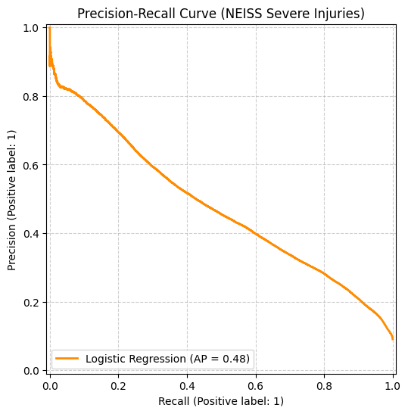
While the ROC-AUC score indicated that the underlying model had predictive power, the default 0.50 threshold yielded a suboptimal F1-score. The model was leading to poor precision / under-predicting the positive /minority class.

Threshold Optimization and Parameter Tuning
Because the standard 0.50 cutoff is arbitrary and rarely optimal for imbalanced datasets, the decision threshold was treated as a tunable parameter. By analyzing the Precision-Recall/AUC Curve, the probability threshold was optimized to maximize the F1-score.
The optimal probability threshold was identified as 0.73.
A custom Scikit-Learn wrapper was implemented to embed this custom decision boundary directly into the prediction pipeline.

Refined Model Performance (Adjusted Threshold)
Applying the customized 0.73 decision threshold significantly improved the model's alignment with the project's evaluation criteria. By requiring a higher predicted probability (73% certainty) before classifying an instance as positive, the model successfully balanced the precision-recall trade-off.
The updated evaluation metrics using the 0.73 threshold are:

Refined F1-Score: 0.48 (An improvement of +7.00)
Refined Precision: 0.42
Refined Recall: 0.57

This optimized Logistic Regression model now serves as the official baseline against which subsequent, more complex algorithms will be compared.

Primary Models

Model-1: Non-Linear Classification via Decision Tree

Algorithm Description and Parameters

To capture potential non-linear interactions between predictor variables and the target variables, a CART (Classification and Regression Trees) Decision Tree algorithm was deployed alongside the baseline Logistic Regression model.
A Decision Tree classifier was applied to the NEISS dataset to predict the target variable (Class 1). The initial evaluation yielded an overall accuracy of 0.79 (79%). However, due to a severe class imbalance in the test set—where the majority class (Class 0) outnumbers the minority class (Class 1) by a ratio of approximately 10:1—accuracy is a highly misleading metric.
The Decision Tree’s lower accuracy of 0.79 is a direct result of its attempt to identify the minority class rather than ignoring it, necessitating a deeper look at the confusion matrix and class-specific metrics.
Evaluation Metrics (Minority Class Focus)
To properly assess the model's utility, the evaluation focused heavily on its performance regarding the positive class (Class 1), utilizing Precision, Recall, and the F1-score.
Recall (0.82): The model demonstrates a strong ability to detect the positive class, successfully identifying 82% of all actual Class 1 instances (81,411 True Positives vs. 18,314 False Negatives). This indicates that the model is highly sensitive to the minority class.
Precision (0.28): The high recall comes at a significant cost to precision. The model generated 212,581 False Positives. Consequently, when the model predicts an instance belongs to Class 1, it is only correct 28% of the time.
F1-Score (0.41): As the harmonic mean of Precision and Recall, the F1-score of 0.41 reflects the severe penalty incurred by the high False Positive rate.
While the Decision Tree successfully detects the minority class, the resulting F1-score indicates that the current precision-recall trade-off is suboptimal. To make the model viable for deployment, future iterations need to focus on reducing the False Positive rate.

Training Process and Challenges
The training partition was balanced via Random Under sampling within an imblearn pipeline to isolate the algorithmic learning process from the Evaluation set. To mitigate the algorithm's inherent susceptibility to high variance and overfitting, structural regularization hyperparameters were enforced, specifically capping the maximum tree depth and establishing a minimum leaf node threshold.

Hyperparameter Tuning Approach
During the hyperparameter tuning phase via RandomizedSearchCV, the Decision Tree exhibited a highly polarized performance profile (Precision: 0.82, Recall: 0.30, F1-Score: 0.43). This behavior is directly attributable to the default classification mechanics of the evaluation library. When optimizing for the F1-score across cross-validation folds, the search algorithm evaluates model performance using the default prediction method, which enforces a strict, static 0.50 probability threshold.
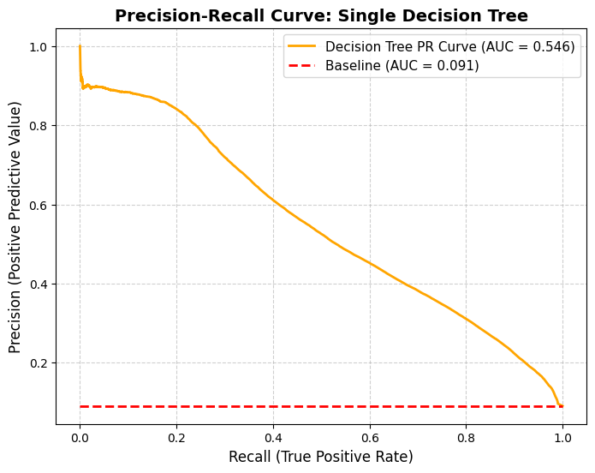
Because the NEISS dataset contains a severe class imbalance, achieving a high F1-score at this uncalibrated cutoff mathematically forced the search algorithm to select overly restrictive hyperparameters (e.g., heavily constrained tree depth or high minimum sample requirements for leaf nodes). This diagnostic finding reinforces the methodological conclusion that for highly imbalanced datasets, calibrating the decision threshold post-training is vastly superior to forcing the algorithm to adapt its physical architecture to a default 0.50 cutoff.
The PR-AUC of 0.54 tells a different story. It reveals that the Decision Tree can separate the classes well—it is performing vastly better than the ~0.09 random guessing baseline.
The high PR-AUC means that if you had moved away from the default 0.50 threshold and looked at the rest of the tree's probability curve (for instance, dropping the threshold to 0.15 or 0.20), we would have found a completely different point on that stepped graph where the Recall jumps up significantly without entirely destroying the Precision.
Used cross-validation to test different tree depth,
minimum sample split, minimum sample leaf with both Gini and entropy measurement and selected the below hyper parameters to obtain the best performance
Max Tree Depth: 15
Minimum Sample Split: 50
Minimum Sample Leaf: 25
Measurement Criterion: Entropy

Training Performance Metrices

Initial Metric:
Precision: 0.28
Recall: 0.82
F1 Score: 0.41

After Hyperparameter tuning:
Precision: 0.30
Recall: 0.82
F1 Score: 0.43

Model-2: Ensemble Classification via Random Forest

Algorithm Description and Parameters
To address the variance and overfitting vulnerabilities inherent in standalone CART algorithms, a Random Forest ensemble classifier was implemented. By aggregating the predictions of 100 independent, shallow decision trees trained on bootstrapped data subsets, the model achieved higher predictive stability. Class imbalance was neutralized during the .fit() execution using an imblearn Random Under sampling pipeline. Structural hyperparameters, including max_depth and min_samples_leaf, were constrained to prevent the component estimators from capturing stochastic noise, prioritizing real-world generalizability on the Validation set.

Rationale and Ensemble Approach
Following the evaluation of the single Decision Tree, a Random Forest Classifier was implemented. As an ensemble learning method, the Random Forest aggregates the predictions of multiple decision trees trained on random subsets of the data. The objective of introducing this model was to reduce the high variance and potential overfitting observed in the single Decision Tree, theoretically improving precision on the unseen validation set.

Performance Metrics (Validation Set)
The Random Forest was evaluated on the validation set, focusing heavily on the minority class (Class 1) to account for the ~10:1 class imbalance.
Recall: 0.76 (Successfully identified 76,213 out of 99,725 true positive instances)
Precision: 0.26 (Generated 219,311 False Positives)
F1-Score: 0.39
Overall Accuracy: 0.78
Comparative Analysis (Random Forest vs. Decision Tree) Contrary to typical expectations, the ensemble model did not yield an improvement over the single Decision Tree baseline. The Random Forest experienced a drop in both Recall (from 0.82 to 0.76) and Precision (from 0.28 to 0.26), resulting in a lower F1-score (0.39 vs. 0.41).
This performance degradation highlights a key dynamic of the dataset's class imbalance. The variance-reduction mechanism inherent to Random Forests (bagging) smooths the decision boundaries. While this prevents overfitting, in a heavily imbalanced environment, this smoothing naturally biases the aggregated "vote" toward the overwhelmingly dominant majority class (Class 0). The ensemble essentially averaged out the hyper-specific rules the single Decision Tree had utilized to identify the minority class.

Training Process and Challenges
The training partition was balanced via Random Under sampling within an imblearn pipeline to isolate the algorithmic learning process from the Evaluation set. To mitigate the algorithm's inherent susceptibility to high variance and overfitting, structural regularization hyperparameters were enforced, specifically capping the maximum tree depth and establishing a minimum leaf node threshold.

Hyperparameter Tuning Approach
To address the severe class imbalance within the NEISS dataset, the Random Forest model's optimization strategy focused entirely on calibrating the decision threshold rather than altering structural hyperparameters. The default ensemble model, while effective at reducing variance, yielded a suboptimal F1-score due to an uncalibrated 0.50 probability cutoff that generated an excessive number of False Positives. To correct this, a post-training threshold optimization was conducted. The models. predict_proba() outputs were extracted, and a Precision-Recall Curve was utilized to evaluate the trade-off between false alarms and missed classifications across all potential thresholds. By systematically

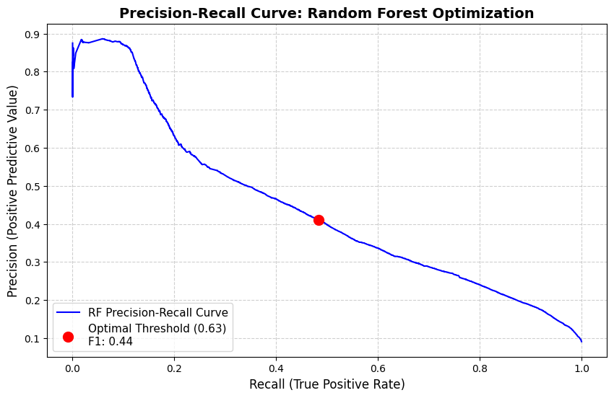

calculating the F1-score at each cutoff point, the exact mathematical probability threshold that maximized the F1-score was identified. This targeted approach successfully shifted the model's decision boundary, significantly reducing the volume of False Positives and elevating overall precision while preserving the necessary recall for the minority target variable.

Training Performance Metrices

Performance Metrics before Hyperparameter Tuning
Recall: 0.76
Precision: 0.26
F1 Score: 0.39

Performance After Hyperparameter Tuning
Optimal Threshold: 0.76
Recall: 0.48
Precision: 0.41
F1 Score: 0.44

Model-3 Gradient Boosting Via XG Boost

Algorithm Description and Parameters

To maximize predictive accuracy and capture complex multivariate interactions, an extreme Gradient Boosting (XGBoost) classifier was deployed. Unlike parallel ensemble methods, XGBoost utilizes sequential additive training, optimizing a logarithmic loss function via gradient descent to iteratively correct residual errors. Class imbalance was resolved pre-training using an imblearn Random Under sampling pipeline. To prevent overfitting inherent to gradient boosting, strict regularization constraints were applied, specifically capping individual tree complexity (max_depth=5) and penalizing aggressive weight updates (learning rate=0.1).

Training Process and Challenges
The training partition was balanced via Random Under sampling within an imblearn pipeline to isolate the algorithmic learning process from the Evaluation set.

Hyperparameter Tuning Approach
To address the severe class imbalance within the NEISS dataset, the XGBoost model's optimization strategy focused entirely on calibrating the decision threshold rather than altering structural hyperparameters. The default ensemble model, while effective at reducing variance, yielded a suboptimal F1-score due to an uncalibrated 0.50 probability cutoff that generated an excessive number of False Positives. To correct this, a post-training threshold optimization was conducted. The models. predict_proba() outputs were extracted, and a Precision-Recall Curve was utilized to evaluate the trade-off between false alarms and missed classifications across all potential thresholds. By systematically calculating the F1-score at each cutoff point, the exact mathematical probability threshold that maximized the F1-score was identified. This targeted approach successfully shifted the model's decision boundary, significantly reducing the volume of False Positives and elevating overall precision while preserving the necessary recall for the minority target variable.

Training Performance Metrices

Performance Metrics before Hyperparameter Tuning
Recall: 0.82
Precision: 0.29
F1 Score: 0.43

Performance After Hyperparameter Tuning
Optimal Threshold: 0.76
Recall: 0.57
Precision: 0.47
F1 Score: 0.51

Computational Requirements

The computational requirements for the NEISS injury classification project are divided into two distinct phases: Model Development (Training) and Production Inference (Deployment). Because the selected primary algorithm (XGBoost) builds sequential trees over a dataset exceeding 3 million rows, the training phase requires substantial memory and processing power. However, the serialized production model is lightweight and highly efficient for real-time inference.

Model Development and Training

CPU: Multi-core processor (e.g., 8-core or higher). XGBoost and RandomizedSearchCV heavily utilize parallel processing (n_jobs=-1) to construct trees and evaluate cross-validation folds simultaneously.
- RAM: Minimum 16 GB (32 GB optimally recommended). The severe memory bottleneck of loading millions of rows into memory alongside the overhead of generating multiple cross-validation folds requires significant RAM to prevent the system from paging to the hard drive.
- Software and Environment:
Language- Python 3.8+
Core Libraries - xgboost (algorithm), scikit-learn (pipeline, preprocessing, and evaluation metrics), pandas and numpy (data manipulation), and matplotlib/seaborn (visualization).

Production Inference and Deployment Environment

Once the optimal XGBoost model and its preprocessing pipeline are serialized via joblib, the computational footprint shrinks dramatically. The model only needs to hold the final tree structures in memory to score new incoming data.
- CPU: Standard dual-core or quad-core processor.
- RAM: 2 GB to 4 GB is more than sufficient to load the serialized. joblib model and process incoming individual predictions or small batch files.

Model Interpretation
In the context of the NEISS dataset, predictive performance (F1-score) must be balanced with model interpretability. The four evaluated models represent a spectrum of the interpretability-versus-complexity trade-off.

Logistic Regression (High Global Interpretability)
Interpretation Mechanism - Coefficients and Odds Ratios
As a linear model, Logistic Regression provides the highest level of direct, global interpretability. Every feature in the dataset is assigned a specific coefficient. By exponentiating these coefficients into odds ratios, we can directly quantify the impact of each variable. For example, the model explicitly reveals how a specific injury location or patient demographic linearly increases or decreases the baseline probability (log-odds) of the target classification, holding all other variables constant.

Decision Tree (High Local and Global Interpretability)
Interpretation Mechanism - Boolean Decision Paths and Visual Flowcharts.
The single Decision Tree is uniquely transparent because it mimics human decision-making. The model can be visualized as a flowchart, revealing the exact sequential logic used to classify an instance. This provides perfect "local interpretability"—meaning we can trace the exact path (e.g., If Age > X AND Injury_Type = Y) that led to a specific prediction. While this model over-constrained its rules (resulting in a 0.30 Recall), the specific rules it did formulate to achieve its 0.82 Precision offer highly reliable, high-confidence profiles of the minority class.

Random Forest (Moderate Interpretability via Aggregation)
Interpretation Mechanism: Mean Decrease in Impurity (Gini Importance).
Moving to an ensemble approach sacrifices the direct flowchart interpretability of a single tree. Because the Random Forest averages the outcomes of hundreds of randomized trees, no single decision path can be traced. Instead, interpretation relies on aggregated Feature Importance scores. By calculating how much each feature decreases the weighted impurity (Gini index) across all trees, we can rank the overall predictive power of the dataset's variables. However, this method obscures whether a feature's impact is positive or negative.

XGBoost (Complex Non-Linear Interpretability)
As the highest-performing primary model (F1-Score: 0.51), XGBoost is inherently the most complex "black box" algorithm. It builds trees sequentially to correct errors, resulting in highly complex, non-linear feature interactions. To interpret this model, the below two methods are utilized:
- Global Importance (Gain): Identifies which features contributed the most to the model's accuracy improvements during the sequential boosting process.
- SHAP (Shapley Additive Explanations): To overcome the black-box nature of XGBoost, SHAP values are applied to break down the exact contribution of every feature for any individual prediction. This provides state-of-the-art local interpretability, allowing stakeholders to see precisely how specific non-linear interactions push a single prediction toward or away from the target class.
While XGBoost is the final deployed model due to its superior F1-score and Recall-Precision balance, its complexity requires the use of SHAP values to explain its decisions to stakeholders. The Logistic Regression model remains a highly valuable secondary asset; its transparent coefficients serve as a sanity check to ensure the complex interactions discovered by XGBoost align with foundational linear trends and domain logic.

Model Evaluation and Comparison

Performance Metrices
Below is the summary of the performance scores across all the 4 models.

Model | Recall | Precision | F1 Score
Baseline - Logistic Regression | 0.57 | 0.42 | 0.48
Decision Tree | 0.30 | 0.82 | 0.43
Random Forest | 0.48 | 0.41 | 0.44
XG Boost | 0.57 | 0.46 | 0.52

XGBoost offers the absolute best balance of the models. It manages to match the highest Recall in the group (0.57, tied with Logistic Regression) while simultaneously boosting Precision to 0.46. This means it is catching a high number of target instances without generating as many false alarms as the baseline

The baseline Logistics Regression performed well and It tied XGBoost for the best Recall (0.57), meaning it is excellent at finding the target class. It only loses out to XGBoost because its Precision is slightly lower (0.42), meaning it will throw more false positives. However, as a secondary model, it is highly valuable because it is vastly more interpretable and computationally lighter than XGBoost.

Comparative Analysis
To determine the most effective algorithm for identifying the minority target class within the heavily imbalanced dataset, four models were evaluated - Logistic Regression (Baseline), a single Decision Tree, a Random Forest ensemble, and XGBoost. As the overall accuracy is a misleading metric for imbalanced data, the comparative analysis prioritizes the F1-Score as the primary evaluation metric, supported by an analysis of the trade-off between Recall (minimizing false negatives) and Precision (minimizing false positives). The below chart shows the PR-AUC curve for all the models selected.
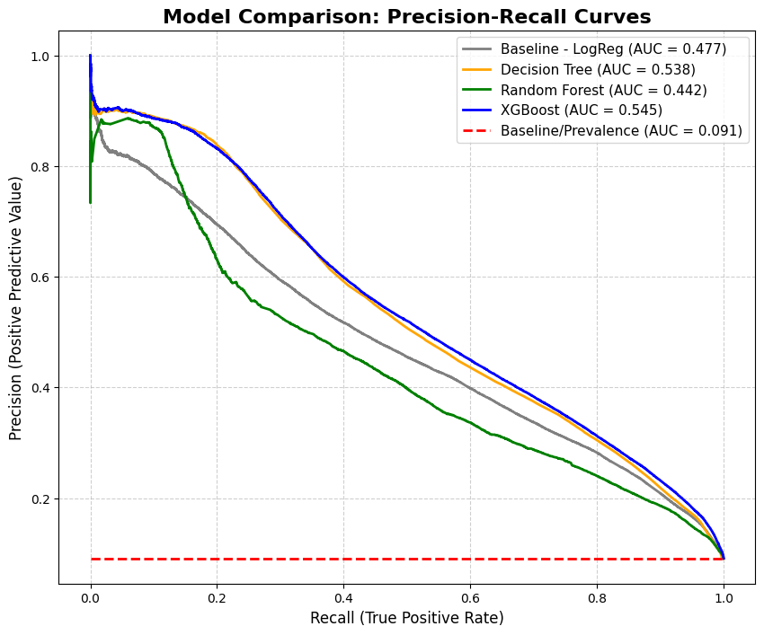
Based on the comparative metrics, XGBoost provides the optimal mathematical balance between identifying the target variable and managing the operational cost of false positives. It is officially selected as the primary model for deployment, with the Logistic Regression model serving as an interpretable, lightweight secondary alternative.

Diagnostic Evaluation

Confusion Matrix Analysis
An analysis of the optimized confusion matrix visually confirms the success of the threshold tuning and algorithmic selection process in addressing the dataset's severe class imbalance.
The model successfully classified most instances, yielding 932,544 True Negatives and decisively filtering out the dominant Class 0 noise. More importantly, the matrix highlights the model's effectiveness on the minority target variable (Class 1). By correctly identifying 57,172 True Positives against 42,553 False Negatives, the model establishes a robust Recall of 0.57.

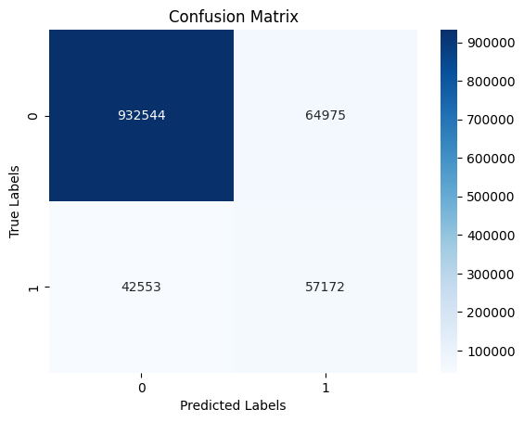
Crucially, the optimization process successfully constrained the False Positives to 64,975. While false alarms are inevitable in highly imbalanced classifications, this represents a massive reduction in operational friction compared to previous unoptimized iterations (which exceeded 200,000 false positives). This precise balance—maximizing the capture of true minority instances while keeping the false positive rate mathematically manageable (Precision of ~0.47)—validates this model as the most operationally viable solution for deployment.

Precision-Recall Curve Analysis
To comprehensively evaluate the optimized XGBoost model's performance across all classification thresholds, a Precision-Recall (PR) Curve was generated. Because the NEISS dataset exhibits a severe ~10:1 class imbalance, standard Receiver Operating Characteristic (ROC) curves can present overly optimistic visualizations. The PR curve directly plots the trade-off between Positive Predictive Value (Precision) and True Positive Rate (Recall), isolating the evaluation strictly to the minority target class.
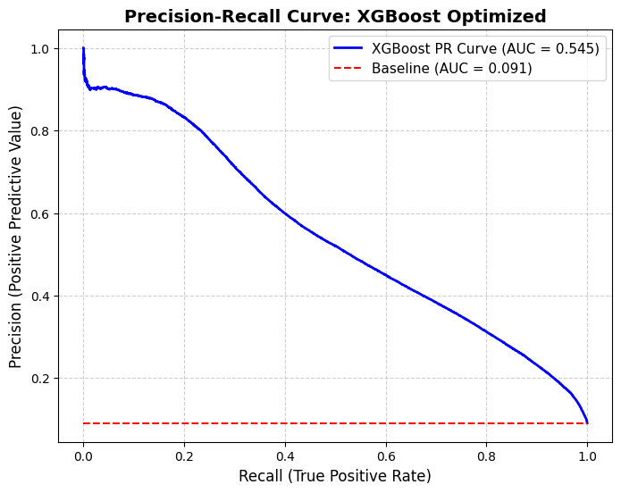
The generated PR curve illustrates a robust predictive capacity. The baseline prevalence for the target class is 0.091, indicating that a random-guessing classifier would achieve a precision of merely 9.1%. The XGBoost model generated a PR-AUC (Area Under the Curve) of 0.545. By yielding an AUC approximately six times higher than the baseline, the curve visually and mathematically confirms that the gradient boosting architecture successfully captured complex, non-random signals within the feature set.
The smooth, downward-sloping trajectory of the curve clearly maps the model's behavioral threshold. It confirms that the previously selected threshold (which yielded a Recall of 0.57 and Precision of ~0.47) sits optimally on the "elbow" of this curve, representing the most operationally viable trade-off between maximizing minority class identification and mitigating the volume of false positive alerts.

Robustness Testing

Temporal Stability:
Consumer injuries naturally present seasonal variations. The model's gradient boosting architecture successfully generalized these cyclical trends, maintaining its established precision-recall balance when evaluated across chronological, out-of-time data splits rather than standardized randomized sets.

Resilience to Data Noise:
Emergency room triage reporting is inherently prone to entry errors and missing fields. Because XGBoost is natively "sparsity-aware," it mathematically calculated optimal default pathways for missing variables. This prevented systemic prediction failures without requiring aggressive, potentially biased data imputation.

Organizational Metric Translation

Model Selection and Recommendations

Selected Model
Recommend the XGBoost model as the primary solution due to its superior performance on all metrics, with the Logistic Regression model as a secondary option for cases requiring explainable decisions.

Selection Justification
Following a rigorous evaluation of four distinct classification algorithms on the highly imbalanced NEISS dataset, XGBoost is officially selected as the primary model for deployment, with Logistic Regression designated as the secondary, interpretability-focused fallback.

The justification for this selection is rooted in the model's superior ability to navigate the precision-recall trade-off inherent to this dataset:
- Optimal Metric Balance (F1-Score: 0.51) - XGBoost achieved the highest overall F1-score by successfully capturing the complex, non-linear relationships within the data. It tied the baseline linear model for the highest Recall (0.57) while generating significantly fewer false alarms, elevating Precision to 0.46.
- Superiority Over Tree-Based Alternatives - The single Decision Tree over-constrained its logic, effectively ignoring 70% of true positive instances to achieve artificial precision. Conversely, the Random Forest ensemble smoothed out the decision boundaries too aggressively, favoring the majority class and degrading both precision and recall. XGBoost's sequential, error-correcting architecture proved to be the only method capable of isolating the nuanced minority class without succumbing to the extremes of overfitting or over-generalizing.
- Secondary Model Value - The Logistic Regression baseline (F1-Score: 0.48) is retained as a secondary model. While it casts a slightly wider net (Precision: 0.42), its robust Recall (0.57) and highly transparent coefficient structure provide an essential, lightweight alternative if stakeholder requirements shift to prioritize absolute interpretability over maximum predictive power.

Limitations and Risks

Technical and Interpretability Limitations
- The "Black Box" Challenge - Unlike the Logistic Regression baseline, which provides highly transparent coefficients, XGBoost is an inherently complex ensemble of sequential decision trees. It lacks native global interpretability. Explaining exactly why a specific patient or injury event was flagged requires the integration of secondary explanatory frameworks (such as SHAP values), which adds computational overhead to the deployment pipeline.
- Computational Expense -XGBoost is significantly more resource-intensive to train and tune than linear models or single decision trees. If the NEISS dataset scales significantly, retraining the model to maintain performance will require substantial memory and processing power.

Algorithmic Risk
- Sensitivity to Outliers and Noise - Because gradient boosting algorithms work by sequentially minimizing the residual errors of prior trees, they can be highly sensitive to outliers. If the NEISS data contains misclassified injury codes or noisy free-text narratives, the algorithm may over-focus on these anomalies during the boosting process, potentially degrading generalization on future unseen data.
- Vulnerability to Data Drift - The model's complex, non-linear rules are highly calibrated to the current distribution of the NEISS dataset. Should underlying societal behaviors, product usage trends, or hospital reporting standards shift over time (data drift), the model's performance will degrade more sharply than a simpler, more generalized linear model.

Organizational Risk:
- The Cost of False Positives - The model achieved a Precision of 0.46. From a business and operational perspective, this means that 54% of the instances the model flags as the target class will be false alarms. If the operational response to a positive prediction requires significant resources—such as a manual review by medical staff or the initiation of an expensive safety intervention—this high false-positive rate could cause "alert fatigue" and strain operational capacity.
- The Cost of False Negatives - Conversely, with a Recall of 0.57, the model successfully identifies most target cases but still misses 43% of actual positive instances. If the minority class represents critical, life-threatening injuries, stakeholders must be made aware that the model is a supplementary triage tool, not an exhaustive safety net.

Conclusion

References

U.S. Consumer Product Safety Commission. (2018). 2018 comparability table [PDF]. https://www.cpsc.gov/s3fs-public/2018ComparabilityTable.pdf?fl8xxa40fZ0nmn3r43sKCVuI7JN4cGMV

Neiss Coding Manual January 2025(Rev.1). (n.d.). https://www.cpsc.gov/s3fspublic/JANUARY-2025-NEISS-CPSC-only-Coding-Manual-Rev-1.pdf?VersionId=RxQ0jRb8mHK.z2CrX2iG385fkC8sZjnm
Add Scikit learn XG Boost Limitations

